Given a **binary tree** root, the task is to return the maximum sum of all keys of **any** sub-tree which is also a Binary Search Tree (BST).

Assume a BST is defined as follows:

* The left subtree of a node contains only nodes with keys **less than** the node's key.
* The right subtree of a node contains only nodes with keys **greater than** the node's key.
* Both the left and right subtrees must also be binary search trees.

**Example 1:**

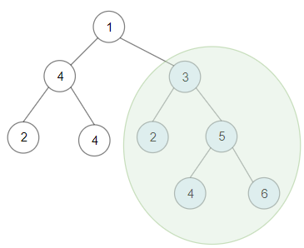

**Input:** root = [1,4,3,2,4,2,5,null,null,null,null,null,null,4,6]

**Output:** 20

**Explanation:** Maximum sum in a valid Binary search tree is obtained in root node with key equal to 3.

**Example 2:**

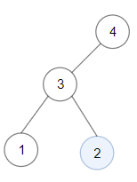

**Input:** root = [4,3,null,1,2]

**Output:** 2

**Explanation:** Maximum sum in a valid Binary search tree is obtained in a single root node with key equal to 2.

**Example 3:**

**Input:** root = [-4,-2,-5]

**Output:** 0

**Explanation:** All values are negatives. Return an empty BST.

**Example 4:**

**Input:** root = [2,1,3]

**Output:** 6

**Example 5:**

**Input:** root = [5,4,8,3,null,6,3]

**Output:** 7

**Constraints:**

* The given binary tree will have between 1 and 40000 nodes.
* Each node's value is between [-4 * 10^4 , 4 * 10^4].